Oracle and Okta Integration
Saturday, January 18, 2025
10:34 AM

Possible Integration methods with WellSky Identity (Okta) for Blood Center's solution (oracle app):

- Blood Center solution is based on Oracle Forms, and we need 'Oracle Access Manager (OAM) with WebGate' to integrate with a federated, enterprise SSO solution.
Currently, the solution does not use the OAM component, so this method is out of scope.
- Okta provides 'Okta Access Gateway' to integrate with apps that do not support federation with user authentication and single sign-on.
Okta Access Gateway is out of scope as it is a considerable effort to set up the pre-requisites.

What is Okta Access Gateway?
Okta Access Gateway enables you to protect access to on-premises apps that don't support federation with the user authentication and single sign-on capabilities of Okta. It's a reverse proxy-based virtual application that integrates with legacy apps using HTTP headers and Kerberos tokens, and offers URL-based authentication. Since Access Gateway is behind the firewall, it lets external users access on-premises web-based apps without the need for traditional VPNs. When deployed, all browser traffic flows first to Access Gateway and then to the back-end protected app. This allows Access Gateway to monitor every request that a user accesses, perform authorization, and add the appropriate headers and tokens to the request.
From <https://help.okta.com/oag/en-us/content/topics/access-gateway/about-oag.htm>

From WellSky Identity Integration team (Kevin Bobson) regarding the Access Gateway setup:
I've reviewed and it seems like there are more server & networking components outside of the Okta scope needed for integrating Oracle Forms. We currently don't support any access gateway configurations so a follow-up meeting will be needed to figure out where to go from here.
https://help.okta.com/oag/en-us/content/topics/access-gateway/about-oag-prereqs.htm

- Use a web app (in PHP) to connect to Okta Identity for authentication and redirect the user to the Blood Center's solution. A client used a similar approach to implement ForgeRock OpenAM (identity SSO) years ago.

We did a sample PHP app for POC. The PHP app is responsible for OKTA authentication, and once successful, it will redirect users to Blood Centers Solution.

Below are a few scenarios for login flow.
- Users log into Okta Dashboard. Click on the 'Blood Centers' Solution tile, and it will direct the user to the Oracle application (Browserless app).
- Users can access the Blood Centers application in any other browser window/tab if they are already logged in to Okta in that browser.
- Users will be redirected to Okta login if not logged into Okta when accessing the Blood Centers Application URL.

Drawbacks/Limitations:

- PHP web app has few dependencies/extensions that are required for Oracle DB connectivity. The OCI8/Oracle compatibility matrix must be verified for every Blood Solution technology upgrade to ensure no connectivity issue.
Dependencies for PHP: OCI8 extension and Oracle Client libraries.
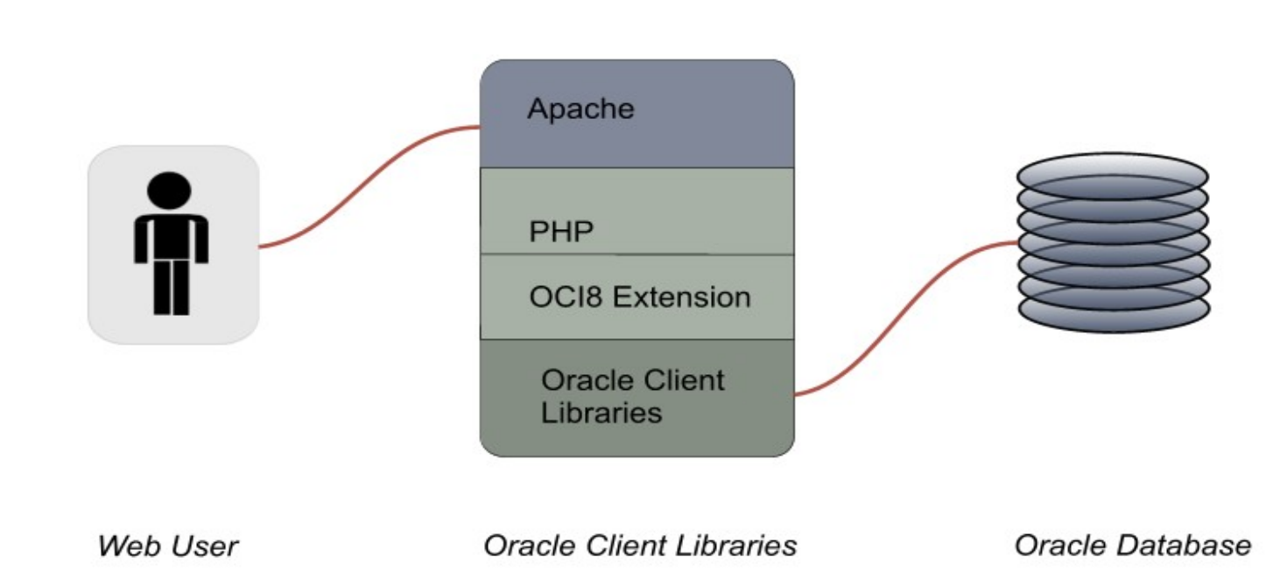
- In Blood Center's solution, we have various screens where a user has to enter user id and password in a sign-off window to continue the transaction (override scenarios in Registration and other places). The password used here is the application password maintained in Blood Center's database, and it could be different from Okta's user password.

- One identity user may be associated with multiple Blood Center solution user IDs. E.g., One person uses multiple application user id's to perform different operations within the application.

- Many clients also have the solution to operate in an offline mode without any internet connectivity. Okta Authentication may not be available in such scenarios.

- Only one application user id can login to the application at any time.

  - Eg: Different users for below screens.
    - RES1 and RES2
    - OBS1 and OBS2
    - TECH1 and TECH2
    - RECONCILE – has to be a different user.

